Photovoltaic Hosting Capacity of Feeders

*Abstract*— This paper is about the configuration of a distribution network that has a maximum hosting capacity of a large-scale PV power station has been investigated. The hosting capacity is expressed by the maximum capacity of the PV power station injected into the distribution network without power quality deterioration such as violations of voltage constraint of the distribution feeder. The created technique runs simulations based on a high-resolution realistic data set of PV injection nodes, daily PV output profiles, and daily load profiles that were randomly selected. OpenDSS and MATLAB are used to construct the simulation setup. In the IEEE 123-node distribution feeder, the performance of the suggested technique is examined for several scenarios.

Keywords — Hostin Capacity, PV, Distribution Feeders

# INTRODUCTION

In the last decade, distributed energy sources (DERs) are commonly used in power distribution systems. As the price of renewable energy sources has decreased, the integration of renewable energy sources into the distribution feeders has increased especially PV systems. The decrease in PV panel cost has globally increased the PV installation in the distribution grid. The International Energy Agency (IEA) estimates that by 2050, solar photovoltaic (PV) power generation will contribute to 16% of the world’s electricity, with 20% of the total PV capacity from residential installations. Residential PV allows local power generation, consumption, and exporting of surplus energy to the distribution grid. When we consider the total energy generation from renewable energy is increasing by %2.9 every year **[1] [2]**Therefore, such applications are important for the future.

Recent research has been focused on increasing the hosting capacity of distribution feeders by some operational changes or upgrades in the grid. Hosting capacity is defined as the total PV that can be injected on a given feeder without any feeder upgrades or modifications. Hosting capacity is referred to as the maximum PV size that does not violate any operating constraints when PVs are connected to any valid node on the feeder. **[3]** These definitions of hosting capacity incorporate that the voltage magnitudes at load nodes in the feeder should remain within the ANSI standards. The research shows that the maximum permissible voltage rise is 1.05 p.u. in the USA according to ANSI standards.**[4]**

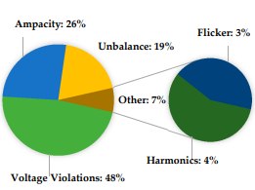

Figure / Percentages of the statistics of PV HC limiting factors in the literature showing voltage

The maximum PV capacity that can be integrated into a distribution grid without experiencing any grid concern is called the PV hosting capacity limit. In this section, the hosting capacity is derived concerning overvoltage concern. The research shows that the maximum permissible voltage rise is 1.1 p.u. in Australia, Italy, Finland, Cyprus, South Africa, and the UK followed by 1.06 p.u. as permitted by Sri Lanka and Qatar. The 1.05 p.u. voltage rise standard is noticed in the USA, Sweden, Denmark, the Philippines, and Indonesia and the most restrictive voltage rise of 1.03 p.u. is practiced in Germany, Switzerland, and China.

In light of the information above, it is important to determine the maximum permissible PV power injection into the feeders.

# DATA PREPARATION

The simulation that we are trying to find the PV hosting capacity requires a dataset which is following: PV output profiles can be found from **[5]**. Renewables. ninja allows you to run simulations of the hourly power output from wind and solar power plants located anywhere in the world. Also, we can get the load profiles from the following **[6]**

# ALGORITHM

In the algorithm, it is necessary to generate the PV points to be added for each scenario first. We randomly generated this to be PV injectable spots. Then we integrated the PV powers as negative charge to the generated points. And we iteratively applied the daily power flow analysis by increasing the PV power step by step. For each phase, we recorded the highest PU voltage magnitude detected during the day and recorded each overshoot point into a string array with PV powers and positions. In order to get an overview for each scenario realized in the last step, we have displayed all the recorded maximum point data on a graph and have seen its general characteristic.

1. CASE STUDIES

The simulations will be done on the IEEE 123-node distribution feeder and the algorithm that we mentioned above will be implemented. Also, such implementations will be performed in the MATLAB and OpenDSS environments.

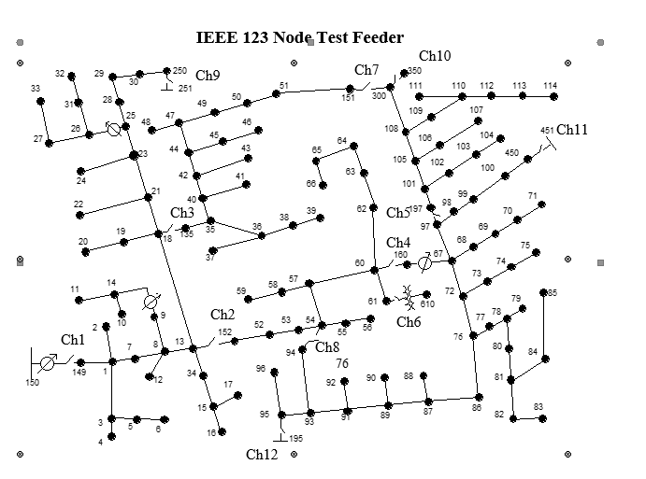

Figure / IEEE 123 Node Test Feeder

To perform such simulations and

Scenario-1: The PV node points generated in each scenario are different. In other words, the characteristics that will be obtained as a result also differ. In the scenario, a result is obtained by injecting only PV powers into the system.

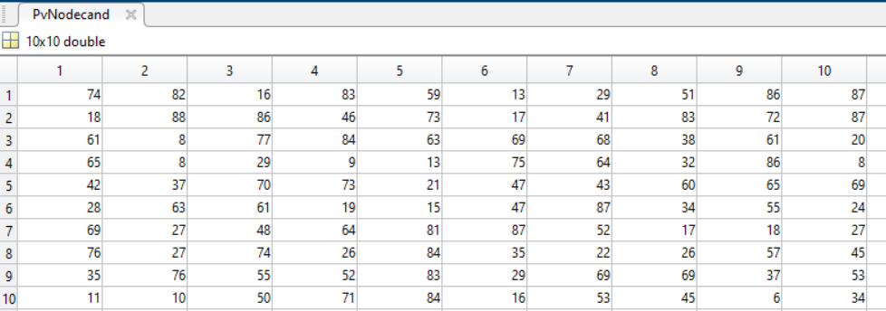

Figure3 An example of PV node points for 10 different senarios



Figure 4 The Maximum Points Charactheristic of the simulations

As can be seen in Figure 4, the maximum phase voltage values taken for simulations involving 10 different scenarios and 100 different PV powers in each scenario were recorded and plotted in PU. Since the power of the PVs increases with each iteration, a step-by-step graph is seen for each scenario.

1. CONCLUSION

This work has been done to the determine PV hosting capacity of the power distribution systems and observed maximum voltage deviations with an injection of PV panels to the nodes to the IEEE 123-node distribution feeder using MATLAB and OpenDSS environment.

To determine the maximum voltage deviations and hosting capacity we implement a method that provides us the information about the overflow changes by incresing the power of the PVs step by step and shows the maximums in a plot and string array variable.

We can see from the simulation result, with the increasing distributed number of the PVs panel in the power distribution network, PV hosting capacity significantly increased.**[7]**

##### REFERENCES

1. *“International energy outlook 2016,” Electric Power Research Institute for U.S. Energy Information Administration., Tech. Rep. 000000003002004777, May 2016. [Online]. Available:* [*http://www.eia.gov/forecasts/ieo/pdf/0484(2016).pdf*](http://www.eia.gov/forecasts/ieo/pdf/0484(2016).pdf)
2. *Understanding Photovoltaic Hosting Capacity of Distribution Circuit - 10.1109/PESGM.2015.7286510*
3. *J. Seuss, M. J. Reno, R. J. Broderick, and S. Grijalva, “Improving distribution network PV hosting capacity via smart inverter reactive power support,” in Proc. IEEE PES General Meeting, July 2015, pp. 1–5.*
4. *Review on the PV Hosting Capacity in Distribution Networks by Samar Fatima, Verner Püvi and Matti Lehtonen, Energies 2020, 13(18), 4756;* [*https://doi.org/10.3390/en13184756*](https://doi.org/10.3390/en13184756)
5. *https://www.renewables.ninja/*
6. [*https://www.nationalgridus.com/Upstate-NY-Business/Supply-Costs/Load-Profiles*](https://www.nationalgridus.com/Upstate-NY-Business/Supply-Costs/Load-Profiles)
7. *O. Ceylan, S. Paudyal, B. P. Bhattarai and K. S. Myers, "Photovoltaic hosting capacity of feeders with reactive power control and tap changers," 2017 IEEE PES Innovative Smart Grid Technologies Conference Europe (ISGT-Europe), 2017, pp. 1-6, doi: 10.1109/ISGTEurope.2017.8260243.*